**Public Transportation Efficiency for Sustainable Development**

Phase 3: Development

Documentation

Project Description:

The aims to conduct a comprehensive analysis of public transportation efficiency with a focus on sustainable development. This project will involve various research and development activities to improve the quality, accessibility, and sustainability of public transportation systems.

Objectives:

1. Assess the Current State: Evaluate the existing public transportation infrastructure, routes, and services in the target area.

2. Data Collection: Gather data on passenger volume, demographics, traffic congestion, and environmental impacts.

3. Efficiency Analysis: Analyze the efficiency of current transportation systems in terms of energy consumption, cost-effectiveness, and emissions reduction.

4. Sustainability Integration: Develop strategies to enhance the sustainability of public transportation by reducing carbon emissions and promoting clean energy alternatives.

5. Technology Implementation: Explore innovative technologies such as electric buses, intelligent traffic management, and mobile apps for passengers.

6. Accessibility Improvement: Ensure that public transportation is accessible and user-friendly for people of all abilities.

7. Stakeholder Engagement: Collaborate with local government, transportation authorities, and community organizations to garner support and input.

8. Public Awareness: Raise public awareness about the benefits of efficient and sustainable public transportation systems.

Project Timeline:

This project will be executed over a period of 2 years, divided into phases.

Phase 1 (Months 1-6):

- Data collection and analysis.

- Establish partnerships and stakeholder engagement.

- Identify sustainability benchmarks and goals.

Phase 2 (Months 7-12):

- Develop strategies for efficiency improvement.

- Explore funding opportunities and project financing.

- Pilot technology implementation.

Phase 3 (Months 13-18):

- Implement sustainability measures and technology upgrades.

- Monitor and evaluate the impact of changes.

- Create public awareness campaigns.

Phase 4 (Months 19-24):

- Finalize project reports and recommendations.

- Present findings to local authorities and the public.

- Develop a roadmap for future development and continued improvement.

Budget:

The project budget will depend on the scope and scale of the public transportation system in the target area. Funding sources may include government grants, private sector investment, and public-private partnerships. An estimated budget will be developed during the initial phases of the project.

Expected Outcomes:

- Improved public transportation efficiency.

- Reduced carbon emissions and environmental impact.

- Enhanced accessibility for all members of the community.

- Increased public awareness of the benefits of sustainable public transportation.

This will serve as a model for other regions aiming to improve their public transportation systems, with a focus on sustainable development.

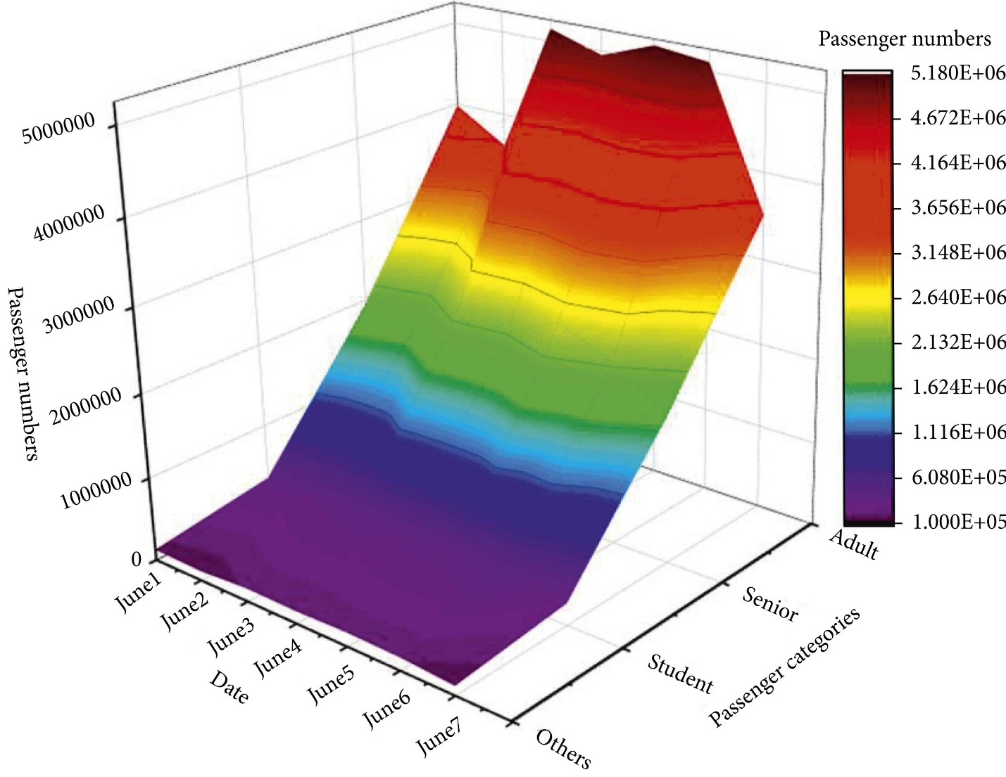Graph: